
Azure Cloud Migration Solution
Process Overview

Cognizant Microsoft Business Group
20 North Wacker Drive #530
Chicago, IL 60606

Notice of Confidentiality ©2021 Cognizant Microsoft Business Group All rights reserved.

IS SUBJECT TO THE TERMS OF THE COGNIZANT MICROSOFT BUSINESS GROUP NON-DISCLOSURE AGREEMENT. NEITHER THIS DOCUMENT NOR ITS CONTENTS MAY BE REVEALED OR DISCLOSED TO UNAUTHORIZED PERSONS OR SENT OUTSIDE THE AFOREMENTIONED COMPANY WITHOUT PRIOR PERMISSION FROM COGNIZANT MICROSOFT BUSINESS GROUP.

Table of Contents
Summary 3
Migration Solution Delivery 4
Phase 1: Project Setup 5
Stakeholders during Project Setup 5
Tasks and Responsibilities during Project Setup 5
Phase 2: Workload Discovery and Solution Design 6
Stakeholders during Workload Discovery and Solution Design 6
Tasks and responsibilities during Workload Discovery and Solution Design: 6
Phase 3: Landing Zone Preparation 7
Stakeholders during Landing Zone Preparation 7
Sub-Phases / Milestones of Landing Zone Preparation 7
Tasks and responsibilities during Landing Zone Preparation 7
Phase 4: Migration 8
Stakeholders during Migration 8
High-level Phases and Milestones of a Migration 8
Migration Planning 9
The Lifecycle of a Workload Migration 10
The Continuous Discovery and Migration Model 10
Tasks and Responsibilities during Migration 11
Phase 5: Project Closeout 12
Stakeholders during Project Closeout 12
Tasks and Responsibilities during Project Closeout 12
Translating the Phases to an Azure Devops Project 13
Azure DevOps Project Structure 13
Communication Standards 14
Communication Mediums 14
Meeting Structure 14
Documentation Standards 15

Summary
This document describes the proposed Azure Cloud Migration Solution and its framework used to deliver a customer project utilizing a streamlined phased process. Using this approach is designed to aid with workstream management by adapting to an Agile project management style using Azure DevOps, repeatable expected results, and streamlined transition between different teams and business units. The Azure DevOps project framework is intended to enable assigning underlying tasks to multiple teams while maintaining proper project visibility and oversight for the project management team.

Migration Solution Delivery
To streamline the work associated with a large migration, the migration is split into phases. This allows us to carve up workstreams and assign them to the proper program managers and underlying teams. A migration project consists of 5 high-level phases. The phases are as follows and fit into the overall Delivery Management framework as illustrated.
- Project Setup
- Landing Zone Discovery and Design/Remediation
- Landing Zone Preparation
- Migration
- Project Closeout

Delivery Process and Resourcing

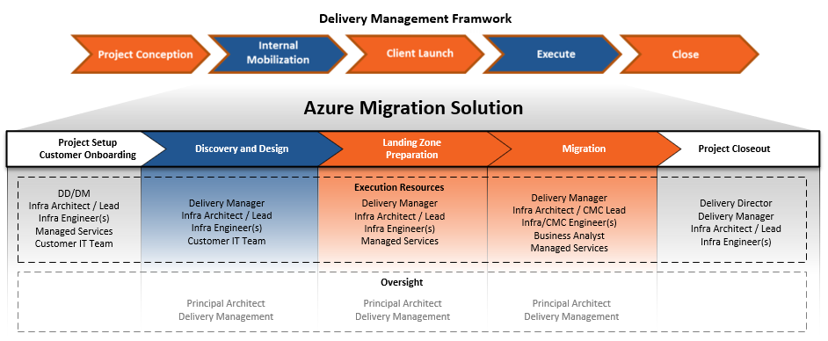

Execution Flow
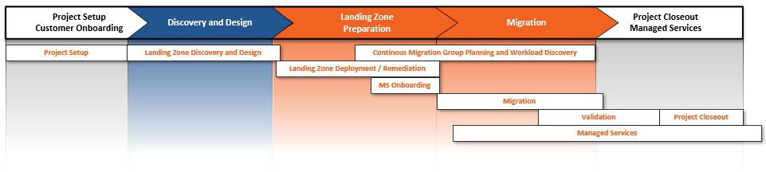

Phase 1: Project Setup

Inputs | Outputs
- Customer information and details from CEA / Sales and workshops, for example: project sizing  - Welcome kit / documentation / diagrams  - Greenfield or brownfield landing zone determination | - Completed welcome kit  - All access and information needed to start discovery  - All prequisite tooling planned and deployed – Azure Migrate / ASR Deployment Planner  - Project framework – DevOps project, internal and externally facing SharePoint sites, internal and externally facing Teams channel  - Scheduled meetings

Stakeholders during Project Setup
- Delivery Director
- Delivery Manager
- Principal Architect
- Infrastructure Architect
- Infrastructure Engineer(s)
- Customer’s Project Management Resource(s)

Tasks and Responsibilities during Project Setup

Task | 10M Responsibility | Customer Responsibility
Handoff meeting from Sales Team to Delivery Team | Execute
Initial Communication
Customer communication, schedule kick-off meeting and initial design sessions | Execute and communicate
Send Welcome Kit, gather documentation | Initiate | Provide
Communication Channel Setup
Create internal/external SharePoint sites | Execute and communicate
Create internal/external MS Teams channels | Execute and communicate
DevOps Project Setup
Create organization for the customer | Execute and communicate
Deploy the VDC project and backlog | Execute and communicate
Customize the DevOps project | Execute
Initial Access and Tooling Setup
Customer Azure subscription details and necessary access | Initiate | Provide
Additional access as required – on-prem vSphere, server or environment administrative accounts | Initiate | Provide
Install Azure Migrate or ASR Deployment Planner and run assessments for migration planning | Execute, collaborate | Collaborate
Ongoing Project Management
Schedule regular project meetings | Execute and communicate | Collaborate

Phase 2: Workload Discovery and Solution Design

Inputs | Outputs
- Completed welcome kit  - Relevant documentation / diagrams  - Design sessions for the following topics:  - Organization Structure, Governance  - Identity  - Workloads  - Network  - Operations | - Compiled relevant information from welcome kit / documentation and design sessions:  - Completed questionnaire from each design session  - Existing environment overview  - Workload requirements  - Deployment process overview and guidelines  - Change control guidelines  - Design recommendations and completed documents for each design session topic  - Cloud Worksheet  - Customer resource(s) assigned to assist with deployment (if applicable)

Stakeholders during Workload Discovery and Solution Design
- Delivery Manager
- Principal Architect
- Infrastructure Architect / Lead
- Infrastructure Engineer(s)
- Customer’s Project Management Resource(s)
- Customer’s IT staff, preferably the following roles:
  - Cloud Architect
  - Senior Network Engineer
  - Senior Systems Engineer
  - Senior Security Engineer
  - Operations Lead

Tasks and responsibilities during Workload Discovery and Solution Design:

Task | 10M Responsibility | Customer Responsibility
Cloud design sessions (onsite preferred) | Initiate and collaborate | Collaborate
Discovery and requirements gathering | Initiate and collaborate | Collaborate
Environment design | Execute and collaborate | Collaborate
Deployment and migration planning | Execute and collaborate | Collaborate
Licensing review with the customer | Execute and collaborate | Collaborate
Create design and recommendations documents, workload migration planning – groupings, server lists | Execute and collaborate | Collaborate
Ongoing Communication
Schedule deep dive and review sessions with workload owners and SMEs | Execute and communicate | Collaborate

Phase 3: Landing Zone Preparation

Inputs | Outputs
- Design documents  - Cloud Worksheet  - Managed | - VDC Landing zone deployed in Azure  - Managed Services onboarded  - Operations foundation configured

Stakeholders during Landing Zone Preparation
- Delivery Manager
- Principal Architect
- Infrastructure Architect / Lead
- Infrastructure Engineer(s)
- Customer’s Project Management Resource(s)
- Customer’s IT staff, preferably the following roles:
  - Cloud Architect
  - Senior Network Engineer
  - Senior Systems Engineer
  - Senior Security Engineer
  - Operations Lead

Sub-Phases / Milestones of Landing Zone Preparation
The Landing Zone Preparation is roughly defined in 6 sub-phases. Each of these should align to a feature and completion will be marked as a milestone in the overall migration execution phase.
- Governance and Core Scaffolding
- Networking Setup
- Identity Setup
- Workload / Template Setup
- Managed Services Onboarding, if applicable
- Operations Setup by Managed Services, if applicable

Tasks and responsibilities during Landing Zone Preparation

Task | 10M Resources | 10M Responsibility | Customer Resources | Customer Responsibility
Complete Cloud Design Worksheet | Project Architect/Lead | Execute | -
Deploy and personalize landing zone (VDC) | Project Architect/Lead  Infra Engineer  CMC | Execute and collaborate | Infra Team | Collaborate
Setup operations foundation | Project Architect/Lead  Infra Engineer  CMC | Execute and collaborate | Infra Team | Collaborate
Manged Services onboarding, if applicable | MS | Execute and collaborate | PM/Infra Team | Collaborate
Ongoing Communication
Continued sessions with workload owners to develop migration planning. | DD/DM  Project Architect/Lead | Execute and collaborate | PM/Infra/App Teams | Collaborate

Phase 4: Migration

Inputs | Outputs
- Welcome Kit  - Migration Plan  - Workload and server groupings  - Migration group schedule that includes lifecycle for each group – discovery, replication, test cutover, cutover.  - Workload Information (Migration Worksheet)  - Migration prerequisites  - Detailed source and landing zone information  - Workload owners and contacts | - Functional VDC  - Functional workloads  - Documentation, lessons learned

Stakeholders during Migration
- Delivery Manager
- Principal Archtect
- Infrastructure Architect / Lead
- Infrastructure Engineer(s)
- Customer’s staff, preferably the following roles:
  - Project Manager
  - Cloud Architect
  - Senior Network Engineer
  - Senior Systems Engineer
  - Senior Security Engineer
  - Operations Lead

High-level Phases and Milestones of a Migration
Migration execution can be broken down into the following sub-phases.
- Migration Tooling Setup – Setup ASR or Azure Migrate. Work with the customer to provide a design that meets their needs and then deploy.
- Up-front Planning and Discovery – Perform pilot and initial workload discovery, prioritize, estimate timelines and schedule migrations.
- Perform a Pilot Migration – Identify a low impact workload to migrate for tooling and process testing and demonstration. Start discovery of the next workload group.
- Continuous Discovery and Migration
  - Perform discovery on the workload(s) in the group. Compile prerequisistes and workload information and formulate a plan and timeline. When complete, begin discovery on the next workload or group.
  - Replicate the Servers in the Workload – Install any necessary agents and establish replication.
  - Perform Failover Testing – Perform isolated failover testing to verify the servers boot and perform as expected in Azure.
  - Cutover – Cut over the workloads to Azure and perform any post-failover configuration.
  - Validation and Handoff – Provide support for the customer while they validate workload functionality and performance. Obtain customer signoff that the migration is complete and hand off to the customer or Managed Services for ongoing operational support.
  - Repeat the steps for the next workload or group until all workloads have been migrated.
- Cleanup – Remove any migration tooling components when migrations are complete, if requested.

Migration Planning
Migration planning consists of all planning and scheduling activities, including:
- Working the customer to establish a pace at which their organization can migrate. Many factors should be considered, such as application knowledge and resource availability, workload business criticality, complexity, maintenance window availability, circuit speeds, change control process, etc. For example, if their internet circuit only supports replicating 40 servers per week, we should plan to migrate just under that if possible.
- Working with the customer to identify workloads and when the best time to migrate those workloads would be.
- Creating a high level schedule that is at least 2-3 weeks out. This plan should go out as far in advance as possible. This will allow for proper resource planning and business notification, as well as allowing for some change without affecting the overall project timeline.

Sample Migration Plan Timeline View
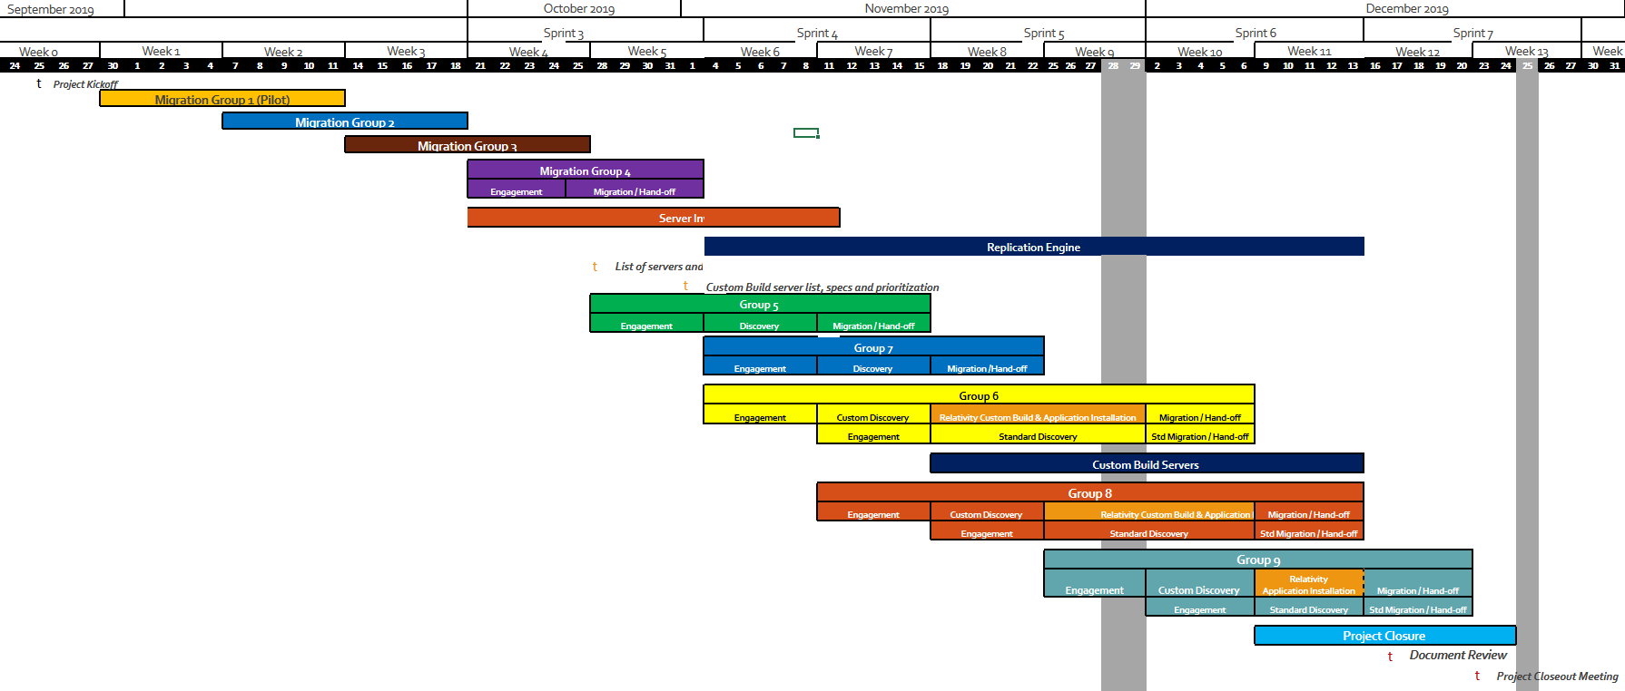

The Lifecycle of a Workload Migration
Discovery, replication, failover testing, failover, and handoff make up the lifecycle of a workload or workload group migration. Each workload or workload group lifecycle is tracked in the CMC DevOps backlog and should also be tracked in the Migration Plan as well as any RAID items in a RAID Log. The lifecycle duration will vary from workload to workload depending on the complexity and size (amount of servers) within the workload.

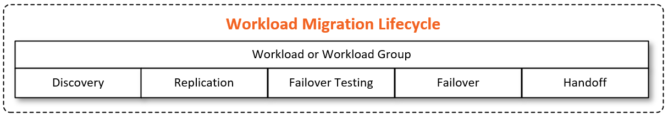

The Continuous Discovery and Migration Model
The goal of continuos discovery and migration is to accelerate migrations by creating a repeatable cycle in which discovery can be completed in parallel to migrations. This model allows for fast and efficient migrations and is best suited for large migrations or migrations with timeline constraints.
To start continuous discovery and migration – the first workload discovery is completed by the project lead or business analyst. As soon as discovery is complete, workload is handed off to the CMC to begin migration activites. While the CMC is migrating the workload, the project team moves on to discover the next workload. This process repeats until all workloads are migrated. In order for the process to be successful, there must be a clear path forward and workloads must be ready for discovery and migration when resources are available. The example below depicts the process. The sprint and timeline per workload may vary depending on the complexity and number of servers in the group.

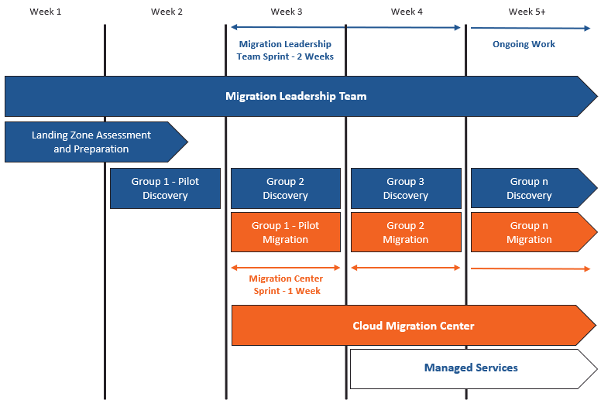

Tasks and Responsibilities during Migration

Task | 10M Resources | 10M Responsibility | Customer Resources | Customer Responsibility
Tooling Setup
Install and configure migration tooling, tooling support | CMC / Migration Team | Execute and collaborate | Infra Team | Execute and collaborate
Workload Onboarding
Migration planning – grouping, establish lifecycle timeline for each workload | DD/DM  Project Architect/Lead | Execute and collaborate | PM Team | Collaborate
Workload cloud licensing review | Project Architect/Lead | Collaborate | PM/Infra Team | Execute and collaborate
Ongoing workload discovery | Project Architect/Lead Business Analyist | Execute and collaborate | PM/Infra/App Teams | Collaborate
Complete Migration Worksheet for workload groups | Project Architect/Lead | Execute and collaborate | -
Establish replication of workloads | CMC / Migration Team | Execute and collaborate | Infra Team | Collaborate
Configure alerts on Site Recovery events in each Recovery Services Vault | CMC / Migration Team | Execute and collaborate | -
Complete workload failover testing | CMC / Migration Team | Execute and collaborate | Infra/App Teams | Collaborate
Cutover
Cutover workload groups | CMC / Migration Team | Execute and collaborate | PM/Infra/App Teams | Collaborate
Validate workloads | CMC / Migration Team | Execute and collaborate | Infra/App Teams | Execute and collaborate
Transition workloads to Managed Services after cutover | CMC / Migration Team | Execute and collaborate | -
Cleanup – remove mobility agents, decommission ASR components, etc | CMC / Migration Team | Execute and collaborate | Infra Team | Execute and collaborate
Customer signoff | DD/DM  Project Architect/Lead | Collaborate | PM/Infra/App Teams | Execute and collaborate

Phase 5: Project Closeout
Inputs | Outputs
- Completed VDC  - Completed migration  - Completed documentation | - Documentation package  - Useful artifacts and lessons learned  - Satisfied customer

Stakeholders during Project Closeout
- Delivery Director
- Delivery Manager
- Infrastructure Architect / Lead
- Customer’s Project Management Resource(s)

Tasks and Responsibilities during Project Closeout

Task | 10M Responsibility | Customer Responsibility
Customer communication | Initiate | Collaborate
Project sign off | Initiate | Execute
Remaining documentation delivery to customer | Execute

Translating the Phases to an Azure Devops Project
Using a phased approach enables us to easily rationalize the workstreams and translate them to a repeatable DevOps project based on the Agile framework. Below is an example of how the hierarchy of a DevOps project would look for a typical customer migration project.

Azure DevOps Project Structure

- Each customer will have its own organization created in Azure DevOps to separate from 10M’s internal org.
- Each customer project will be created as a separate new project in their Azure DevOps organization. This allows us to separate multiple initiatives or reference past projects for the customer.
- Each project will have teams created that are focused on a specific backlog – for example the VDC team members will have a backlog specific to VDC activities.
- Each project should have an Epic for each major project phase containing a hierarchy of all the milestones and work items.
- Each subphase should align to a feature with larger milestones aligning to stories with subtasks.
- Specific tasks should be nested in the user stories for assignment to engineers actually doing the work.
- Sprints are 2 week blocks. Aligning work to sprints is completed in a planning meeting the week prior to the start of a new sprint.
- Each project will have one or more repos for builds. The repos should be cloned from master template repos.
- Any project related artifacts that were used or developed during the project – like ARM templates, scripts, custom configurations, etc should be uploaded to the project repos.
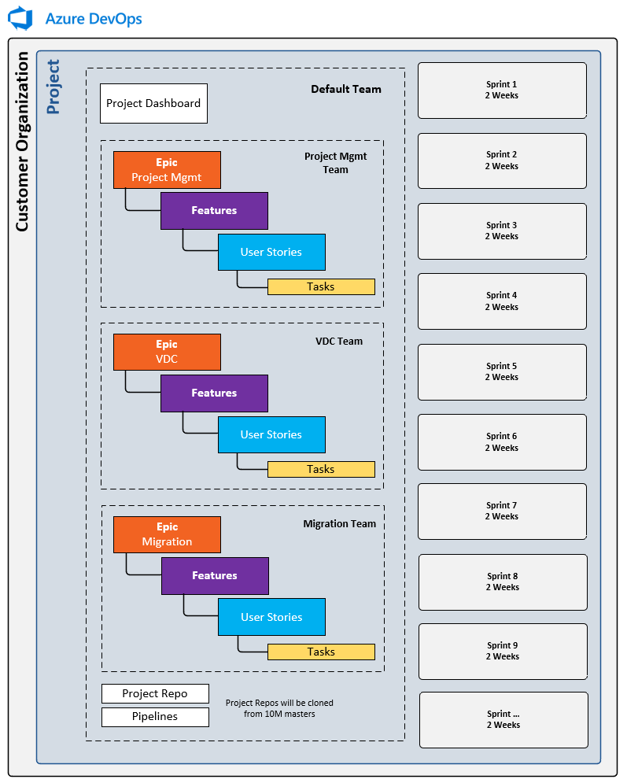

Communication Standards
In efforts to ensure we are consistent in the way we communicate among the team and with customers, below is a breakdown of the communication standards and meeting structure.

Communication Mediums

10th Magnitude’s internal Microsoft Teams instance is the preferred method of ad-hoc communication, meetings, and design sessions. During project setup, 2 teams channels are created for communication – an externally facing channel for direct customer communication and file sharing, and an internal only channel for internal team collaboration and file sharing. Email is ok too, just be sure to copy the project team on communications for awareness.

Meeting Structure

Meeting | Visibility | Frequency | Duration | Agenda
On-Site Kickoff | External | One Time | 1-3 Days | Engagement Introduction  Discovery sessions  Stakeholder Review
Sprint Planning | External | Every 2 weeks -  week prior to planned sprint | 30-60 min | Planning work for the upcoming sprint  Review work completed and move any remaining work from the previous sprint to the current sprint.
Project Status | External | 1-2 per Week  (depends on project size/complexity/customer working abilities) | 1-2 hours | Get updates from each group on progress and work completed  Discuss next steps for a timeframe  Discuss resources and time allotment  Work through blockers
Stakeholder Review | External | Every 2 weeks | 30 min | Executive updates on project status  Discuss blockers
Working Sessions | External | As Needed | 1-2 hours | Sessions with the customer's teams for additional technical deep-dive discovery or completing work items
Internal Sync | Internal | Weekly | 30 min | Discuss project and blockers  Develop and discuss strategy

Documentation Standards

In efforts to ensure everyone can find the information that is needed when its needed, below is a breakdown of where each type of documentation should be stored.

Document | Location
Sales / Marketing material, presentations, templates | SharePoint DCT Catalog
SoW Templates | SharePoint DCT Catalog
Customer checklists, questionnaire templates | SharePoint DCT Catalog
Delivery templates – Migration worksheet | SharePoint DCT Catalog
Public Shareable Technical Documentation / Guides | SharePoint DCT Catalog
Customer project related deployment templates, scripts | Related customer DevOps project artifacts
Customer project related technical documents | SharePoint
DCT/CMC/MS team IP and how-to documentation | DevOps Wiki
Base deployment templates, useful scripts, examples | DevOps Wiki

